Views - Assignment 11
- Create a view that shows all of the customers who have the highest ratings. 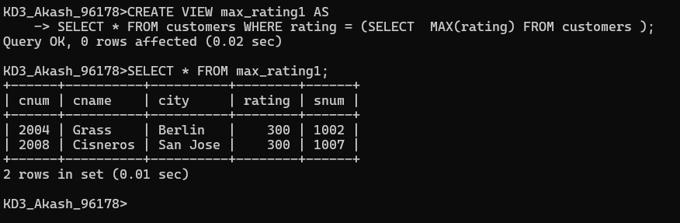
2) Create a view that shows the number of salespeople in each city.
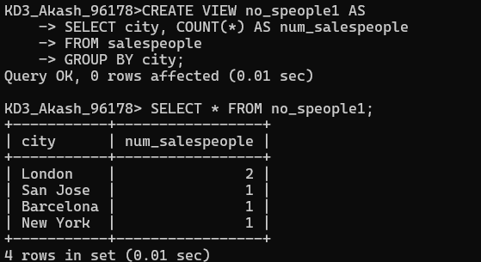

3) Create a view that shows the average and total orders for each salesperson after his or her name. Assume all names are unique.
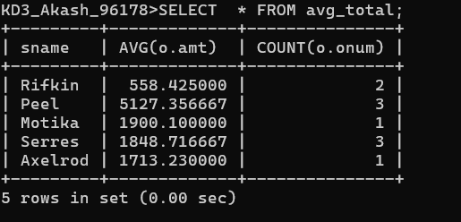

4) Create a view that shows each salesperson with multiple customers. Changing Values through Views.
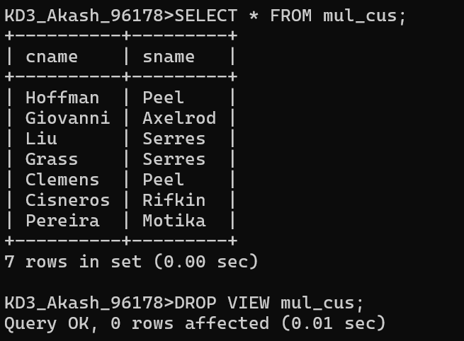
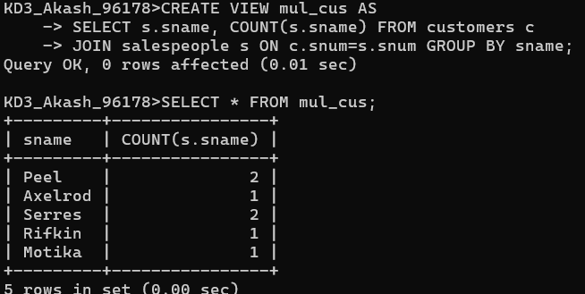

6) Create a view of the Salespeople table called Commissions. This view will include only the snum and comm fields. Through this view, someone could enter or change commissions, but only to values between .10 and .20.
